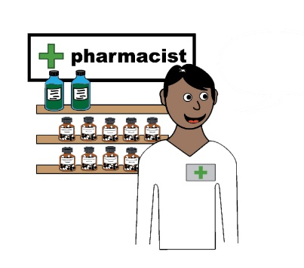
Tell us about using your local pharmacy.
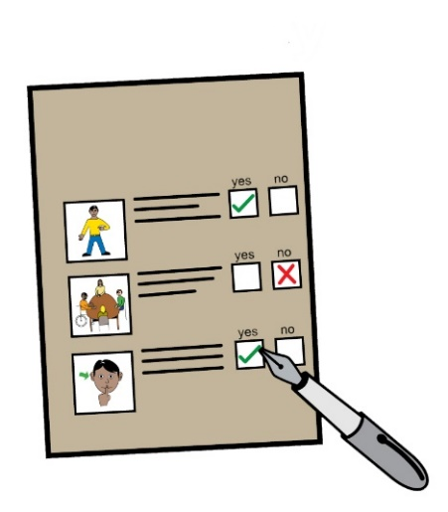

Please answer
these questions.

Your answers will help make pharmacy services
better.

How you use pharmacies

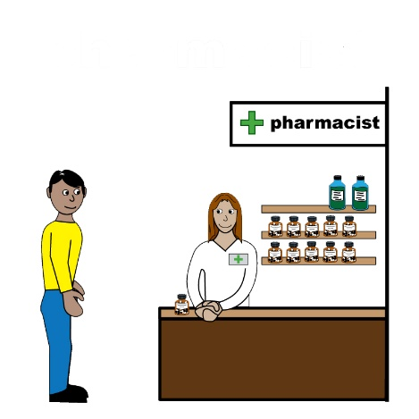
- How often do you visit a pharmacy?
at least once a week
at least once a month
at least once every 3 months
at least once every 6 months
at least once a year
less than once a year

2.Has COVID-19 changed the way you use pharmacies?
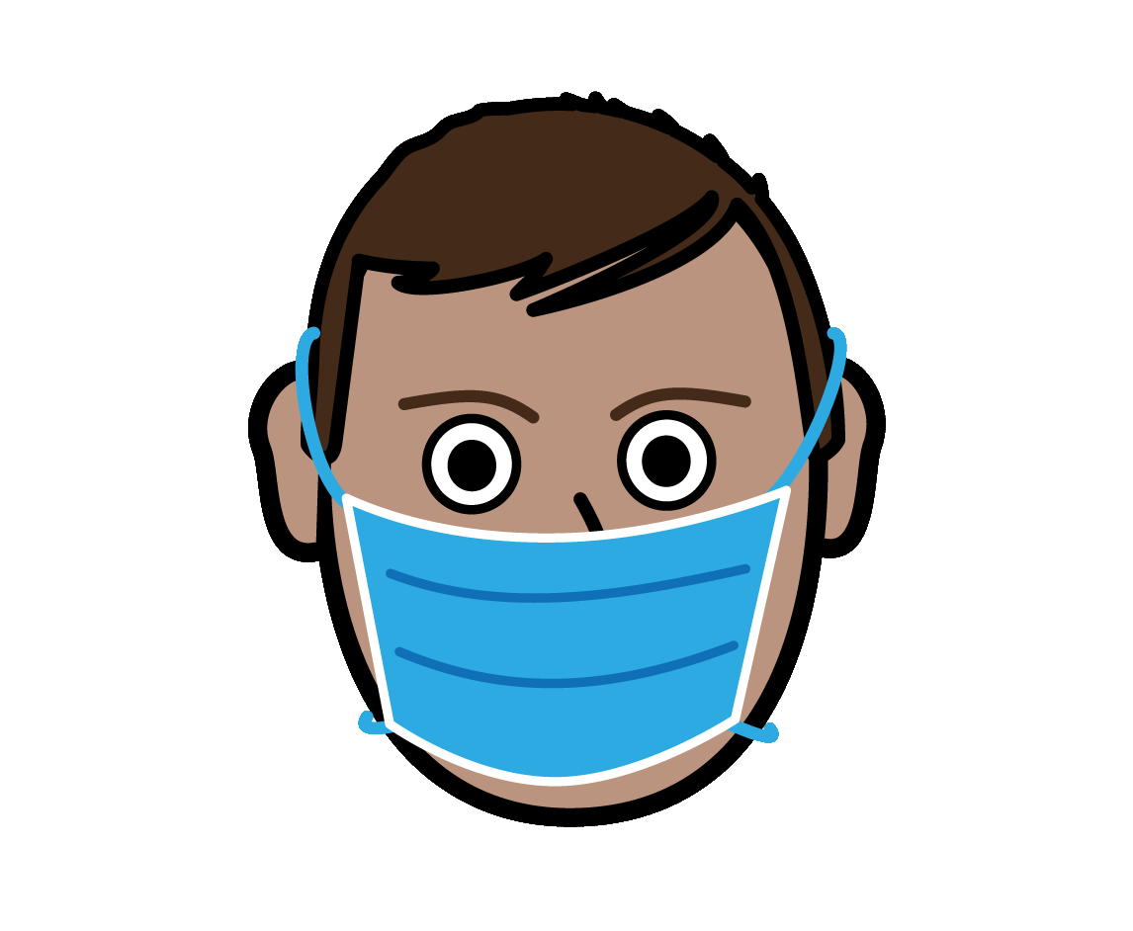
I go to the pharmacy more often
I go about the same amount
I go less often
I get home deliveries
I use online pharmacies

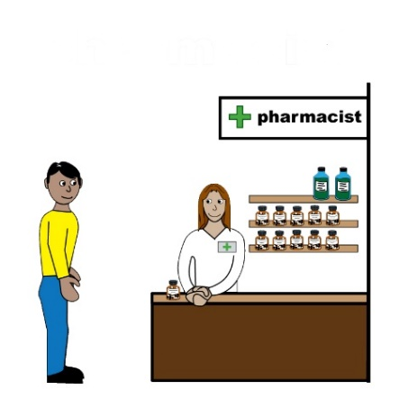
3.Do you always visit the same pharmacy?

Yes
Usually
No

4. How do you usually get to the pharmacy you visit most?
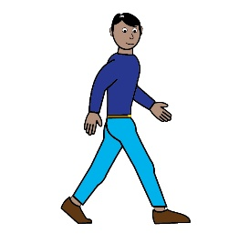

On foot
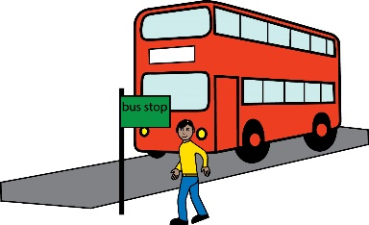
By public transport. This could be a bus or a train.
In a car or taxi
Another way. Please tell us what this is.

5.How easy or difficult is it to get to your local pharmacy on foot or by public transport from your home?

on foot public transport
Very easy Very easy
Easy Easy
Difficult Difficult
Very difficult Very difficult
I don’t know I don’t know

6.What type of pharmacy do you visit?
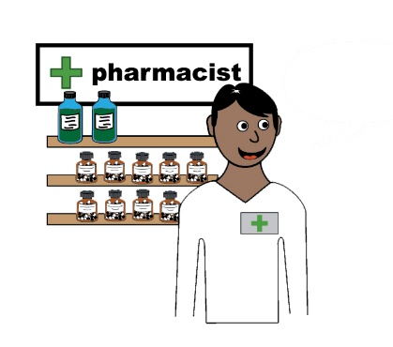
High Street pharmacy
Pharmacy in a supermarket

Pharmacy in your doctors surgery
Online pharmacy

Another type of pharmacy. Please tell us what this is.

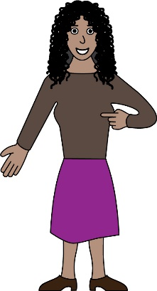
7. Do you have a disability?

Yes
No

- If you do have a disability, please tell us if your pharmacy helps with the things below.
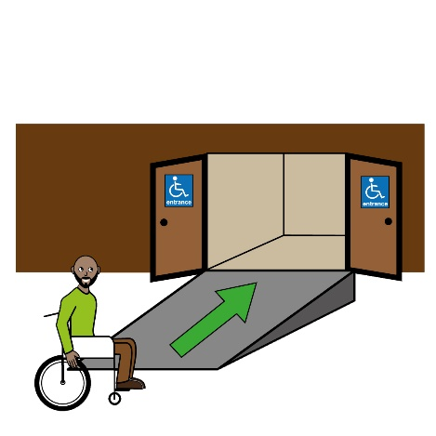
Wheelchair access
Yes
No
Don’t know
This doesn’t apply to me
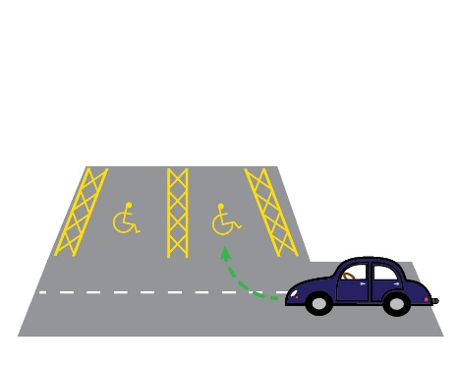
Disabled parking
Yes
No
Don’t know
This doesn’t apply to me

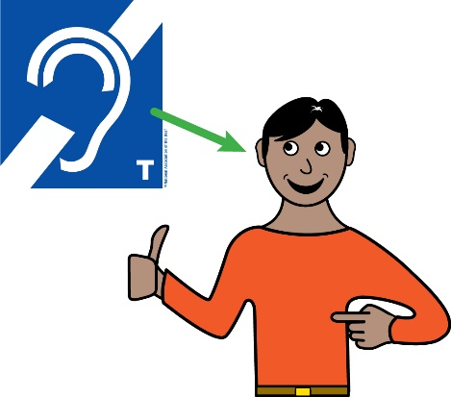
Help with hearing or sight loss
Yes
No
Don’t know
This doesn’t apply to me
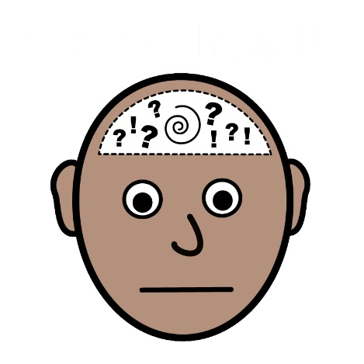
Help with mental health issues
Yes
No
Don’t know
This doesn’t apply to me
Help with learning disabilities
Yes
No
Don’t know
This doesn’t apply to me

- Does your pharmacy provide information in other languages or offer interpretation services?
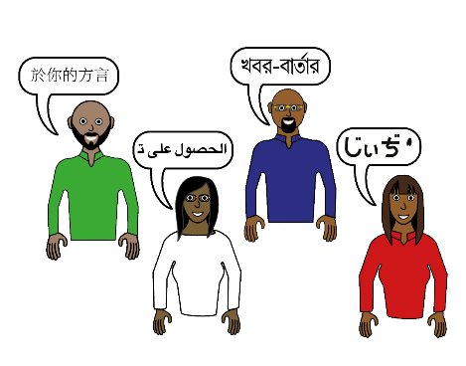
Yes
No
Don’t know

- Is there another pharmacy closer to your home that you don’t use?
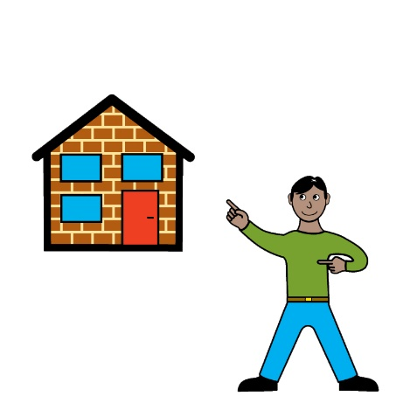
Yes
No
If yes please tell us why you don’t use this pharmacy.

- Which day of the week do you go to the pharmacy most often?
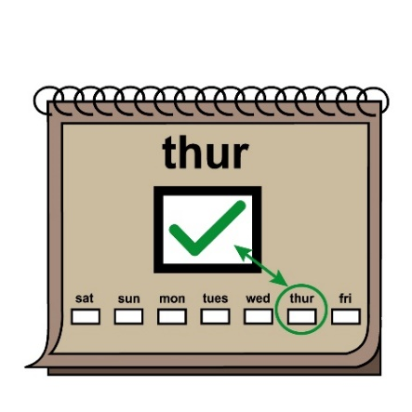
Monday
Tuesday
Wednesday
Thursday
Friday
Saturday
Sunday
I don’t know/I go on different days

- How do you feel about the hours that your pharmacy is open?
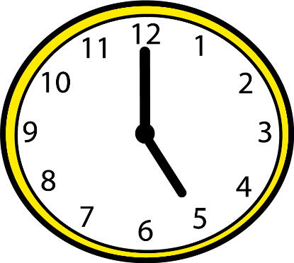
Very unhappy
Unhappy
Okay
Happy
Very happy

- Have you ever needed something from your pharmacy but found it was closed when you visited?

Yes
No
I don’t know
If you said yes please tell us what you needed at the pharmacy.

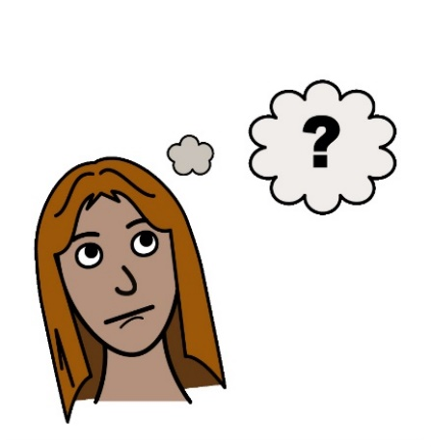
- If you answered yes to question 13 please tell us what you did when you found the pharmacy was closed.

- Is there anything else you would like to tell us about the pharmacy you use or a pharmacy close to your home that you don’t use?
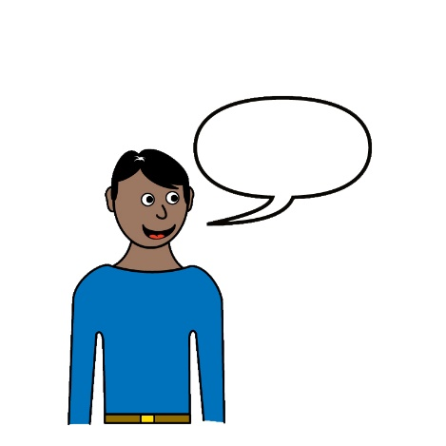

About You

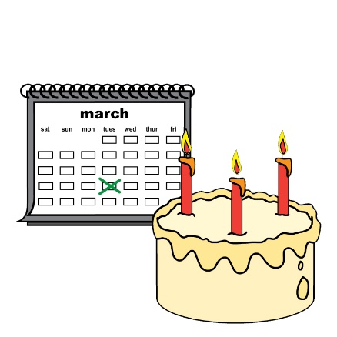
16. How old are you?

Under 15 50-54
15-19 55-59
20-24 60-64
25-29 65-69
30-34 70-74
35-39 75-79
40-44 80-84
  - over 85

17. Are you…
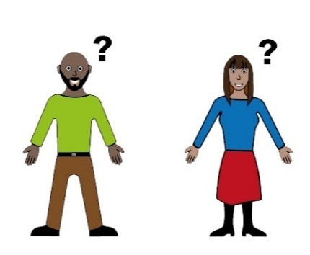
Male
Female
Non-binary – this is neither male nor female
Rather not say

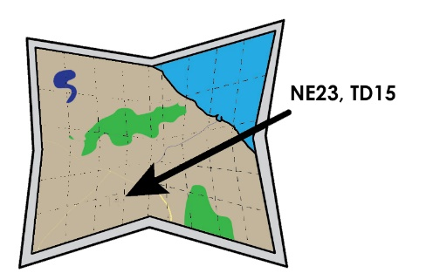
18. What is your postcode?
Your postcode does not tell us your individual address.

- Are you…

White British
White Irish
Any other White background
Mixed White and Black Caribbean
Mixed White and Black African
Mixed White and Asian
Any other mixed background
Asian or Asian British Chinese
Asian or Asian British Indian
Asian or Asian British Pakistani
Asian or Asian British Bangladeshi
Any other Asian background
Black or Black British
Any other Black background
Any other Ethnic Group
Prefer not to say

Thank you. Please email this form to: info@healthwatchnorthumberland.co.uk.
Or post it to: FREEPOST, Healthwatch Northumberland, Adapt (NE), Burn Lane, Hexham NE46 3HN.

More Information

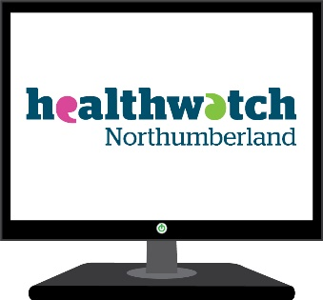
If you need more information please go to our website: www.healthwatchnorthumberland.co.uk

Or contact us by phone on 03332 408468
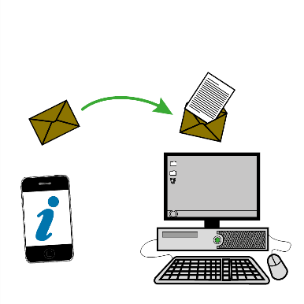

Or email us at info@healthwatchnorthumberland.co.uk

